Tutorial (Discussion 1) – Topic 2(Functions)
Question 1
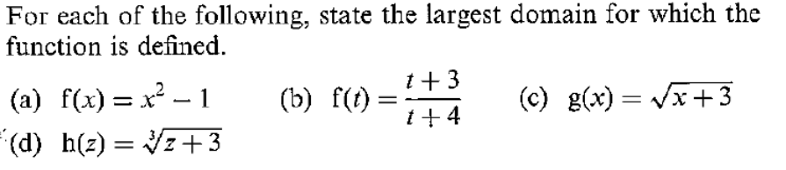
Question 2
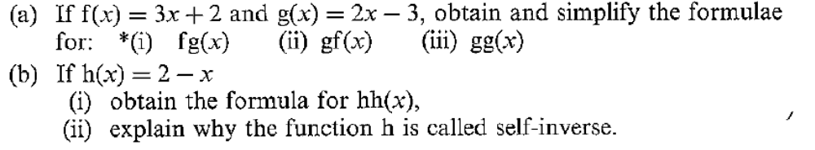
Question 3
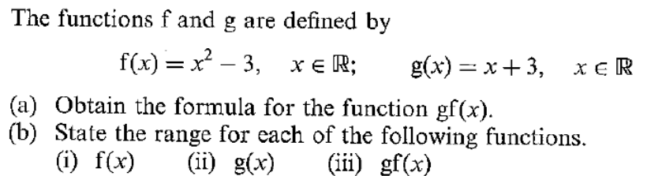
Question 4
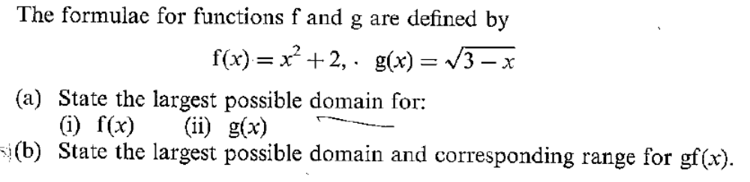
Question 5
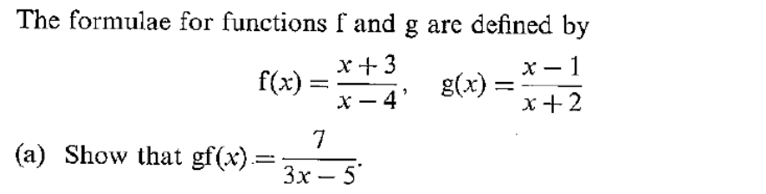
Question 6
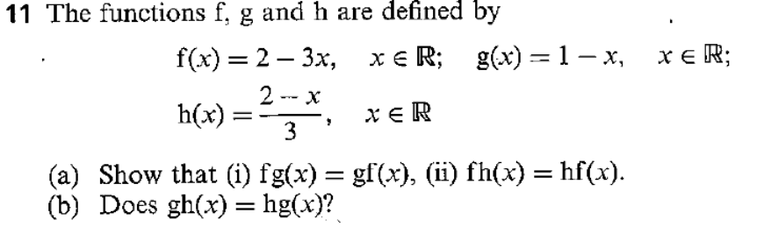
Question 7
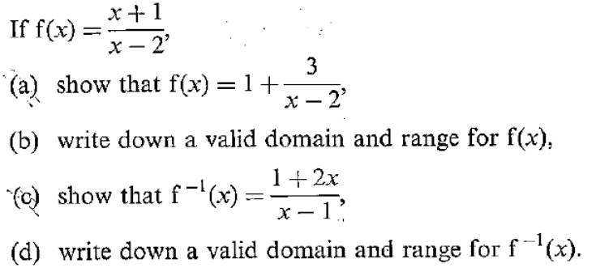
Question 8
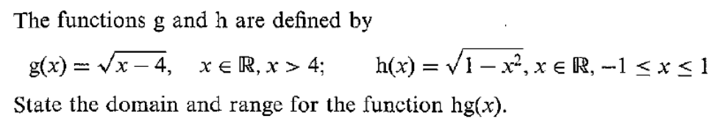
Question 9
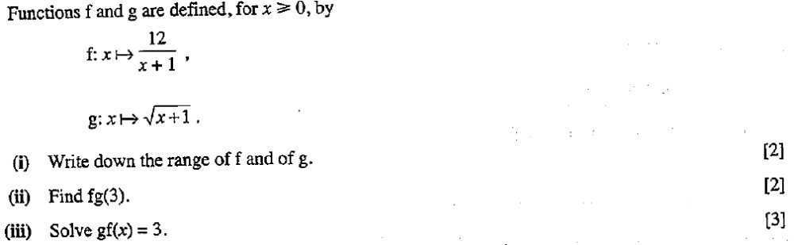
Question 10
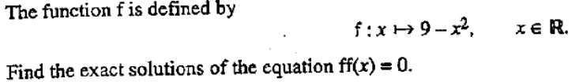

Tutorial (Discussion 2) – Topic 2 (Functions)
Question 1

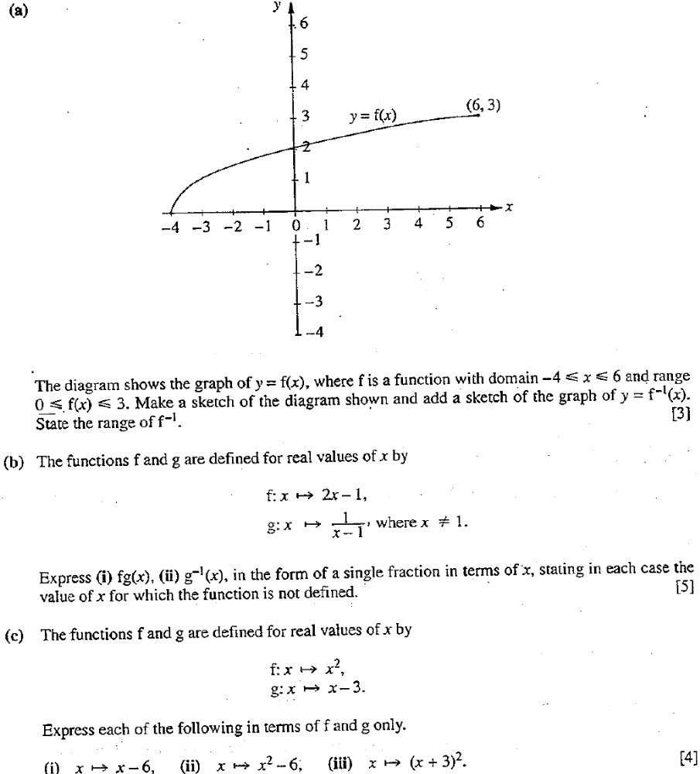

Question 2
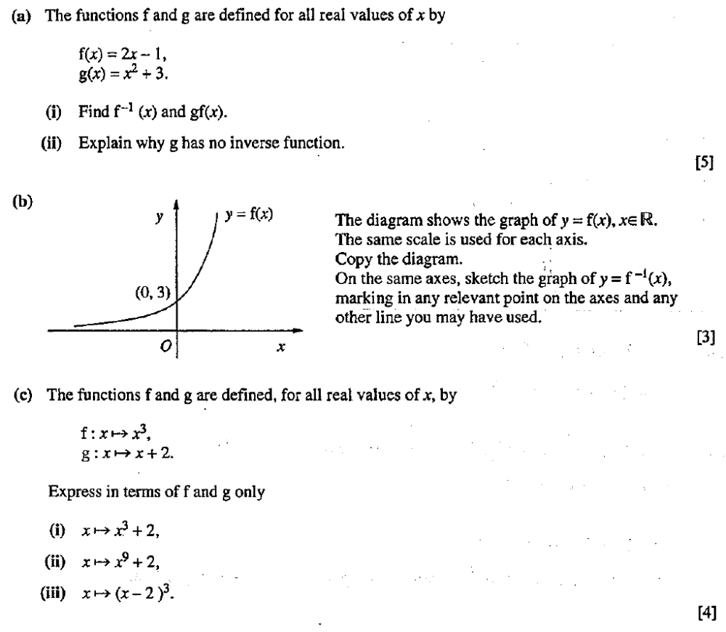
Question 3
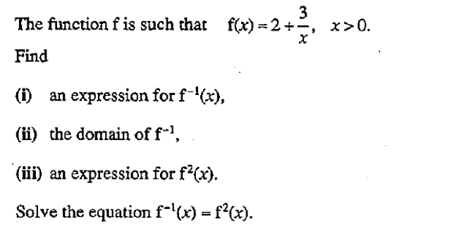

Question 4
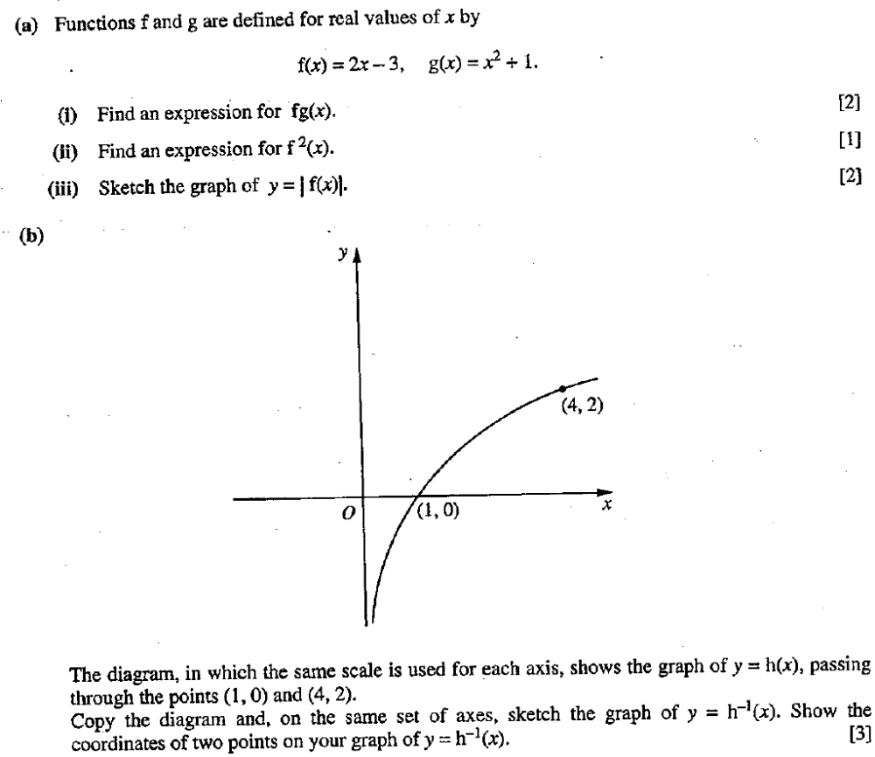
Question 5
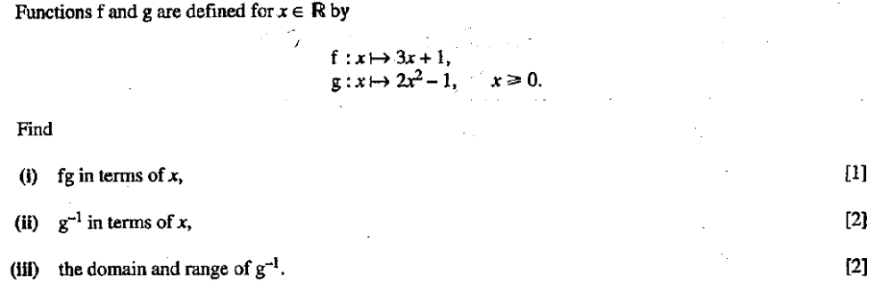

Question 6
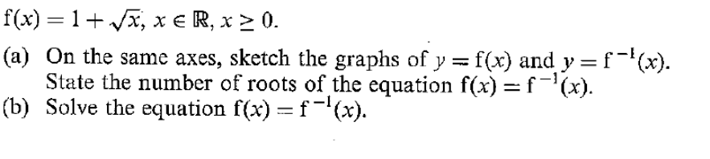
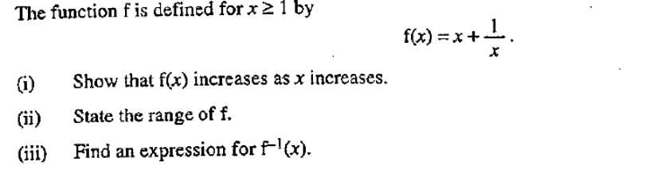
Question 7
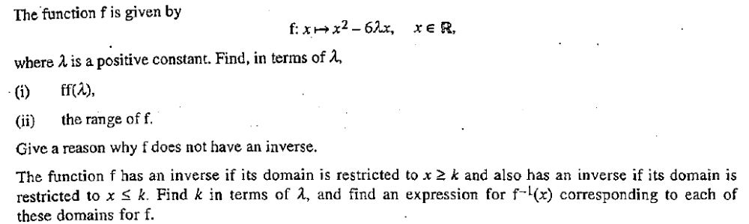
Question 8
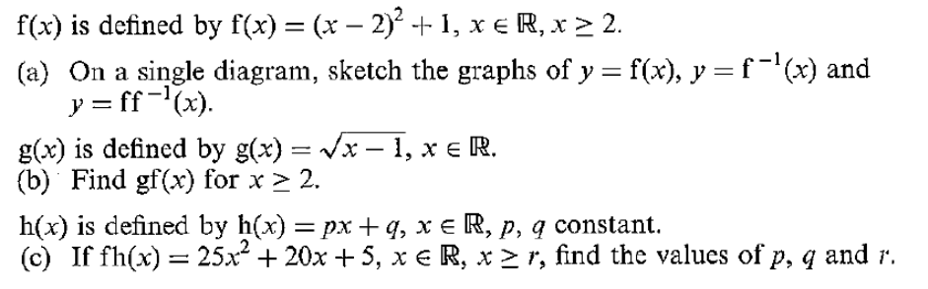

Oct/Nov 2008 Examination
